**CLUSTERING BASED ON WHALE OPTIMIZATION ALGORITHM FOR IOT OVER WIRELESS NODES**

**ABSTRACT:**

The Internet of Things relies heavily on wireless sensor networks (WSNs) (IoT). However, the energy resources of sensor nodes in a WSN-based IoT network are restricted. By grouping nodes into clusters to reduce the transmission distance between sensor nodes and base stations, a clustering protocol offers an effective method for ensuring node energy savings and extending network lifespan (BS). Current clustering protocols, on the other hand, have problems with the clustering mechanism, which has a negative impact on their efficiency. We suggest an enhanced energy-efficient clustering protocol consists of sensor nodes, collecting data from each sensor node is a challenging task, there exists a various types of clustering techniques are present for an efficient clustering. So, we are implementing a new Clustering Routing Algorithm Based on Whale Optimization Algorithm (WOA) which is so better at clustering of sensor nodes without a considerable energy overhead. Rather clustering through depending on the energy of nodes, WOA decides of whether a node will participate or not in the election of a Cluster Head (CH). Thereby, decreasing energy dissipation at a very considerable value.

**EXISTING SYSTEM:**

The LEACH protocol  is the first proposed clustering protocol. The main idea is to choose the CH in a clustered manner at each round and then have the nodes join the closest CH to form a dynamic cluster. This network topology is built on the chosen CHs, which is inefficient due to the lack of consideration for node residual energy.  Furthermore, prioritising CH selection results in the forming of complex clusters at each round, resulting in an increase in energy overhead due to cluster formation after each re-selection phase for CHs .A LEACH-centralized protocol (LEACH-C) is another variant of the protocol in which the optimum number of clusters K is calculated using a statistical model. In comparison to LEACH, Base Station BS is in charge of CH selection and cluster creation by the use of the simulated annealing optimization procedure, in which nodes with more than the average energy send their information to the BS at the end of each round.

**DISADVANTAGES:**

1. LEACH does not give any idea about the number of cluster heads in the network.

2. One of the biggest disadvantage of LEACH is that when due to any reason Cluster head dies, the cluster will become useless because the data gathered by the cluster nodes would never reach its destination i.e. Base Station.

3.Some cluster heads at the center of the cluster and some cluster heads may be in the edge of the cluster; this phenomenon can cause an increase in energy consumption and have great impact on the performance of the entire network.

4. CH selection is the most difficult part of dynamic clustering.

5.Inaccurate determination of the optimal number of clusters when using current mathematical models because the distance to the CH has not been estimated correctly.

6. In LEACH-C nodes, energy overhead persists, and the round trip is time-consuming throughout the CH selection process. The main disadvantage in existing method is the unbalanced energy consumption

**PROPOSED METHOD:**

Firstly, There exists a number of techniques for clustering of nodes in a WSN, but none of them are good at clustering, they results in extending the lifetime of the nodes of the network but, not on the clustering. We are implementing a new technique known as Whale Optimization Algorithm (WOA). WOA is an algorithm that works on mainly the fitness function for reducing and balancing energy consumption and network coverage. The WOA starts with the initial set up phase, which generates a set of random solutions for a problem. The solutions are improved over time during the process, whenever the solutions will be better. Unlike, the remaining algorithms WOA takes into account the neighbors and their respective distances from the base station. The remaining energy Erem is also taken for the election of cluster heads (CH). The CH will be calculated based on the distances from the BS and their remaining energies. CHs are changed whenever their criteria falls below. Fitness function introduction in this algorithm is a whole new concept when it comes to checking the or selecting the CHs. Fitness function will be calculated at every stage to make the fitness even more robust. After, all of the CHs are selected and the CHs will allocate a Time Division Multiple Access (TDMA) for sending the data to CH which will pass the aggregated packets to the BS.

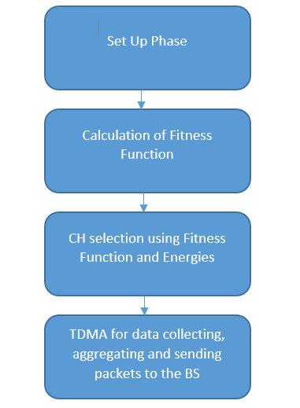

**Block diagram of proposed method**

**ADVANTAGES:**

1. Cluster Heads are calculated based on the fitness function.

2. Calculation of fitness function at every stage of the process makes the CH selection even more robust.

3. Clustering is done through fitness function which results in a better clustering than the previous existing methods.

**APPLICATIONS:**

1.industrial control

2.environmental monitoring,

3. military surveillance,

4.intelligent transportation systems and medical field.

5.Furthermore, it can function independently in harsh or high-risk places where human presence is not possible

6.Disaster relief operations.

7.Biodiversity mapping

8.monitoring of temperature, pressure, and humidity

.

**Software & Hardware Requirements:**

**Software:** Matlab R2018a.

**Hardware:**

**Operating Systems:**

• Windows 10

• Windows 7 Service Pack 1

• Windows Server 2019

• Windows Server 2016

**Processors:**

Minimum: Any Intel or AMD x86-64 processor

Recommended: Any Intel or AMD x86-64 processor with four logical cores and AVX2 instruction set support

**Disk:**

Minimum: 2.9 GB of HDD space for MATLAB only, 5-8 GB for a typical installation

Recommended: An SSD is recommended a full installation of all Math Works products may take up to 29 GB of disk space

**RAM:**

Minimum: 4 GB

Recommended: 8